|  |
| --- |
| Influence of external input and inhibitory synapses on the balance of a sparsely connected network of Leaky Integrate-and-Fire neurons. |
| Bachelor thesis psychobiology |
|  |
| **Jiri Brummer – 10277897 –** [**jiribrummer@gmail.com**](mailto:jiribrummer@gmail.com)  **Supervisor: Fleur Zeldenrust -** [**fleurzeldenrust@gmail.com**](mailto:fleurzeldenrust@gmail.com)  **Second corrector: Lourens Waldorp -** [**waldorp@uva.nl**](mailto:waldorp@uva.nl) |
| **29-5-2015** |

|  |
| --- |
| ABSTRACT TO BE DONE |

Influence of external input and inhibitory synapses on the balance of a sparsely connected network of Leaky Integrate-and-Fire neurons.

*Jiri Brummer, supervised by Fleur Zeldenrust*

Introduction

Cortical cells *in vivo* typically show irregular firing in response to sensory stimuli, whereas these same cells show regular firing behavior in response to current injections *in vitro*(reference). How this irregular firing arises, and what its consequences are, remains an open question. One theory is that the timing of post-synaptic currents from individual cells is synchronized. As a result, the sum of these inputs is high enough to reach action potential threshold …hoe leid dit tot onregelmatig vuren? (Softky & Koch, 1993). A contradictory explanation states that synchronization is not necessary as long as there is a strong balance between excitation and inhibition. The average of the input is subthreshold. Because of the stochasticity of the input, neurons respond to minor deviations from the average, which leads to irregular firing (Shadlen & Newsome, 1998).

In order to examine these hypotheses , researchers have performed simulations on computational models of the human cortex. In computational neuroscience there are numerous neuron and network models, all of them having advantages and disadvantages. Mostly the consideration is based on the computational performance versus biological plausibility (Izhikevich, 2004). Usually, one chooses the simplest model which still contains the minimal features to be able to answer the research question.

When examining the network dynamics of the cortex, simple neuron models are preferred, as the focus is more on the behavior of the network than on that of the single neurons. Moreover, there is always a tradeoff between the complexity of the neuron model versus the size of the network: simple neuron models require less computational power and are therefore more suitable for large network simulations. For the simulation of cortical networks, connections should be sparse and recurrent, like those found in the mammalian brain. A commonly used model is the sparsely connected balanced random network (Brunel, 2000; Remme & Wadman, 2012; Yger & Harris, 2013).

The balanced random network, also called balanced network, is a large-scale network of sparsely connected Leaky Integrate-and-Fire (LIF) neurons. It is called balanced, because the network activity neither attenuates nor increases after initialization, but…wat dan wel?. A LIF neuron uses a linear approximation of the subthreshold membrane potential, and therefore only uses very few parameters. A spike itself is not modeled. The behavior of a balanced network of the simplest LIF neurons is extensively examined, both analytically and computationally (Brunel, 2000).

Brunel (2000) showed that a balanced network can settle in four different states, which are based on synchrony and regularity of what?. The network can reach the synchronous regular state, where single neurons fire regularly with a time constant similar to the refractory period and the network is synchronized. If neurons fire regularly but the indivudual neurons asynchronously, it is called the asynchronous regular state. If single neurons fire irregularly, the network could reach the synchronous irregular and the asynchronous irregular states. The key parameters in the differentiation between these four states are the amount of external input (each neuron receives stochastic background input) and the ratio between the conductance of excitatory versus inhibitory synapses (see Figure 1).

Other studies showed that network models with more biological plausible LIF neurons, in which the synapse is described in more detail, can reach balanced states as well (Yger & Harris, 2013). However, it is still unknown if these networks can reach the different states of synchrony and regularity, and whether the transitions between these states are similar to those of the network with the simpler synapse model. **Therefore, in this thesis I examined whether a network model with more biological plausible synapses can reach the same states as the original network with respect to synchrony and regularity.** It is hypothesized that a balanced state will be reached, and that it is possible to differentiate between the different states, although the exact parameter values at which the transitions occur will differ from the simpler model.

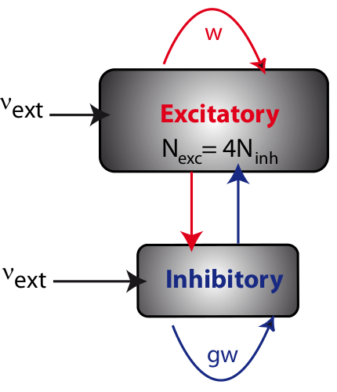The hypothesis is examined by implementing a balanced network of LIF neurons and systematically quantifying the regularity of the individual spike trains and the synchrony of the network of different combinations of two parameters: the external input and relative strength of inhibitory synapses, which were the key parameters in *Brunel 2000.* It is expected that it is possible to differentiate between the four states bases on the quantification. Whether these transitions will be nominal or continuously is unknown, as the involved parameters are not linearly correlated to one another.

Materials and Methods

**Figure 1.** **Visualization of a balanced network.** A balanced network with populations of excitatory and inhibitory neurons, each connected both with itself and with each other. Each neuron receives 4 times more excitatory than inhibitory connections. Moreover each neuron receives external input. In this network, w is the synaptic strength of the excitatory connections, g is the relative weight of the inhibitory connections and vext is …... (From http://www.yger.net/the-balanced-network/)

**Simulations**

Simulations of the spiking neural network were performed using the BRIAN 2 simulator (Goodman & Brette, 2009) with a fixed time step and a membrane time constant of . All simulations were performed on a Packard bell EasyNote TK with 4GB RAM and 2,3 GHz AMD Athlon II P360 processor.

**Simple neuron model**

For the simple LIF neuron model (adapted from *Brunel, 2000)* the following equation is used:

where RIi(t) is the input each neuron receives, both from external input and from other neurons in the network. The external input is described by the following equation:

where is the constant external input described by:

,

is the frequency of external input and is the spike-threshold of the neuron. represents the fluctuating input. is described by

,

where represents the PSP amplitude, represents the number of connections of excitatory neurons and represents Gaussian white noise with mean = 0 and SD = 1. Every time a presynaptic spike is fired, the postsynaptic membrane potential is updated according to:

where is the membrane potential after a spike, is the membrane potential before a spike and g is the relative strength of a inhibitory synapse ( for excitatory synapses). The other parameter values were kept fixed at the following values , , the transmission delay , the refractory period and the reset value after a spike Waarom heb je deze zo gekozen? Waar komen die vandaan? The parameters I will investigate are the relative strength of the inhibitory synapses and the external firing rate .Waarom? Waarom deze parameters en niet andere?

The number of excitatory (NE) versus inhibitory (NI) neurons are, resembling the ratio of anatomical estimates for neocortex, respectively 1600 and 400. The sparseness of the network (ε), which is the fraction of the amount of synapses (Ne+Ni) relative to the toal number of possible synapses (Nˆ2) was originally 0.1 (with a total number of neurons of 12500). However, to keep simulations feasible, the number of neurons was scaled down to what number?, so the sparseness has to be scaled as well in order to preserve the same balance (Golomb & Hansel, 2000). This new sparseness value is described by:

where , and After application of this scaling, the sparseness of the network = 0.4098. This means that every neuron has a probability of 0.4098 it receives a connection from any other neuron.

**More complex neuron model**

In the biologically more realistic network, the same neuron model was used as in Brunel 2000, but the synapses were modeled as follows (adapted from *Yger & Harris, 2013*): after a presynaptic spike, not the postsynaptic membrane potential was updated, but a postsynaptic conductance, following a linear differential equation. This conductance change which leads indirectly to a change in membrane potential.

In this network model, the membrane potential of each neuron is given by:

where is the membrane conductance, here defined as . The leak conductance , the resting membrane potential , the threshold , the reset potential and the refractory period .

The synapses are modeled as instant changes in conductance when a spike is triggered, followed by an exponential decay, described by:

where the excitatory and inhibitory synaptic time constant are and respectively and the reversal potentials are and .

To keep the simulations feasible, 800 excitatory and 200 inhibitory neurons are used. The sparseness = .1915, scaled from .05 with 4500 neurons, as described previously. Waar komen deze keuzen/warden vandaan? Synaptic delays are randomly chosen from a uniform distribution between 0.1 and 5 . Initial synaptic conductances were randomly chosen from Gaussian distribution with means and with . Finally, each neuron receives external input from an independent Poisson spike train at 300 , through an excitatory synapse with conductance of . The parameters I will investigate are the mean value of and the value for . Why?

**Quantification of regularity and synchrony of the more complex model**

For the parameters and exploratory simulations, based on previous studies, were performed in order to determine the range of values for the simulations. The range for is between 1 and 10 waarom? Waarop gebaseerd?, for between 2 and 11 , as values <2 result in a network with too little activity en >11 nS?. For these different parameter-values the single neuron activity is quantified for regularity and the network activity for synchrony. The regularity of the network is quantified as the average regularity over its neurons, given by the coëfficient of variation (CV) of the inter-spike interval distribution of each spike train:

where is the average CV value of a network, N the number of neurons in the network and ISI the distribution of the inter-spike-intervals for each neuron.

The synchrony of the network is quantified by the following synchrony measure (SM):

where is the measure for synchrony of the network, freq is the frequency on a time step t and T the number of time steps. The average frequency is corrected for the total activity of a network, so the SM is not biased by the total activity of a network, but merely by the level of synchrony.

**Clustering**

After the quantification of both regularity and synchrony is completed, a k-means analysis was performed in order to objectively cluster the different parameter sets into different states. For the determination of the clusters the Elbow method is used (Ketchen Jr. & Shook, 1996). With this method the number of clusters is plotted against the total distance of the points of a cluster to the centre of that cluster. This distance usually decreases as the number of clusters increases. Initially the decrease is high and there usually is a flipping point after which the decrease is much lower. This is called the elbow point, and the value of the number of clusters of that point is used for the k means analysis. For the k means analysis the synchrony and regularity data are scaled so both variables have the same weight in the determination of clusters. For the scaling each data point is divided by the total of the variable, so a fraction is used for the analysis.

Results

Firstly, we wanted to check that/reproduce … of In order to…. Wat is het doel? Beschrijf nogmaals doel hele onderzoek, en dan ‘deeldoel’ van simulaties hier. The first step towards what goal? was to examine whether the same balanced states as *Brunel, 2000* could be reached with the smaller network. The Synchronous Regular (SR) state was reached with . The Synchronous Irregular (SI) state was reached with . The Asynchronous Regular (AR) state was reached with . The Asynchronous Irregular (AI) state, was reached with (see figure 2). Since the smaller network could indeed reproduce the results of Brunel (2000), we proceeded with extending the model with the more complex synapse model in order to see whether that model could reach these four different states as well.

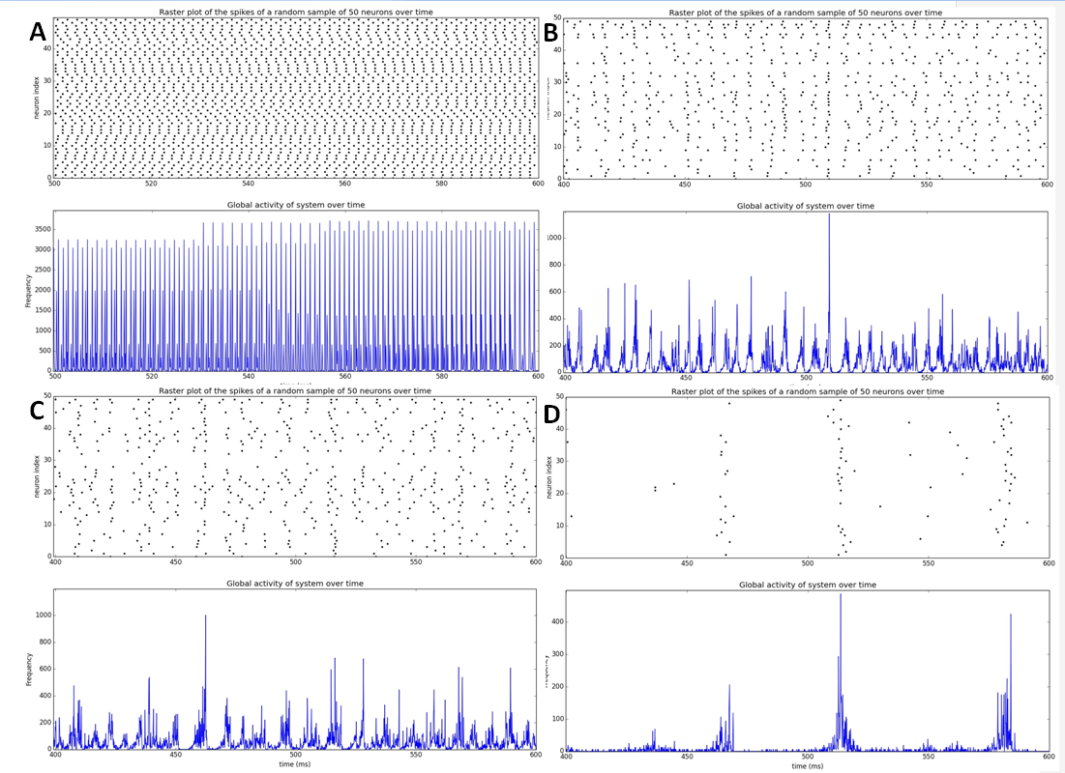To examine the behavior of the activity of the (small) network with the extended synapse model, initial parameter values of *Yger & Harris, 2013* () were taken as starting point. With these values there was no balance, so the external input was increased to in order the reach a balanced state. From this point an explorative simulation was conducted to find the ranges of interest to find different balanced states. Simulations were conducted with between 1 and 10 and between 1 and 10 . This resulted in different states of the balanced network.

**Figure 2.** **Classification of different states of a balanced network of the simple neuron model.** Simulation of a network of 1600 excitatory and 400 inhibitory neurons with a sparseness of 0.4098. For all four situations the spiking behavior of 50 randomly chosen neurons of the population is shown in the upper plot, and the global activity of the network in the lower plot. **A.** The Synchronous Regular (SR) state, where neurons are synchronized and neurons spike regularly (only the during refractory period the neurons are silent; ). **B.** The Synchronous Irregular (SI) state, where there is synchrony in the global activity, but single neurons fire irregularly (). **C.** The Asynchronous Regular (AR) state, where the network activity is asynchronous, but single neurons do tend to fire regular (). **D.** The Asynchronous Irregular (AI) state, where the network activity is asynchronous, and single neurons spike irregularly ().

When the external input was too low () there was too little activity to speak of a balanced network. When the external input was increased and the inhibitory synaptic strength was kept low, the network reaches the SR state. When the synaptic strength of the inhibitory synapses was increased, roughly between and , the network reaches a state that was not described in the original network by Brunel (2000): a Bursting Synchronous state (BS; see Figure 3). When inhibition is increased more, the network activity shows a state similar to the AI state. Without quantification it is hard to determine whether these are SI and AR states. Therefore simulations were performed again to calculate the objective measure for regularity and synchrony.

**Figure 1.** **Classification of different states of a balanced network of the simple neuron model.** Simulation of a network of 1600 excitatory and 400 inhibitory neurons with a sparseness of 0.4098. For all four situations the spiking behavior of 50 randomly chosen neurons of the population is shown in the upper plot, and the global activity of the network in the lower plot. **A.** The Synchronous Regular (SR) state, where neurons are synchronized and neurons spike regular (only the during refractory period the neurons are silent; ). **B.** The Synchronous Irregular (SI) state, where there is still synchrony in the global activity, but single neurons fire irregular (). **C.** The Asynchronous Regular (AR) state, where is much less synchrony, but single neurons do tend to fire regular (). **D.** The Asynchronous Irregular (AI) state, where the frequency is too low to speak of synchrony, and single neurons spike irregular ().

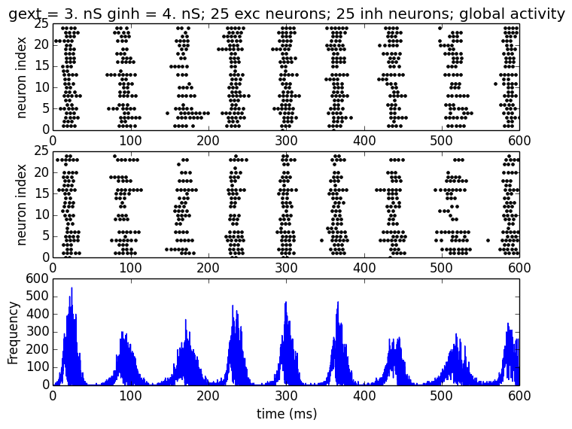To be able to differentiate between the different states objectively, the Coefficient of Variation (CV) and the Synchrony Measure (SM) (see: Methods) were calculated for regularity and synchrony respectively. A low CV value means that the neurons on average spike regularly, CV values around 1 mean that on average the neural spike trains are similar to a Poisson process, and therefore highly irregular. The different values of the CV are plotted in Figure 4. The figure shows that values of , independent of the value of , all cause very regular spiking behavior. is a transition value, and all values of cause very irregular behavior.

**Figure 3.** **Network activity of a network in the Bursting State (BS).** Simulation of a more complex neuron network of 800 excitatory and 200 inhibitory neurons with a sparseness =0 .1915. The spiking behavior of 50 randomly chosen neurons of the population is shown in the upper plot, and the global activity of the network in the lower plot. Parameters used are and the network shows bursting behavior.

For synchrony a similar approach was? used; a high SM value signifies synchronous behavior. The SM values are plotted in figure 4. Values of show very synchronous behavior. Moreover, for low values of the network shows more synchronous behavior than higher values of . When the measures for regularity and synchrony are combined, the SR state, for , is easily visible O ja? Why? How?. But to classify the other states, objective quantification is needed.

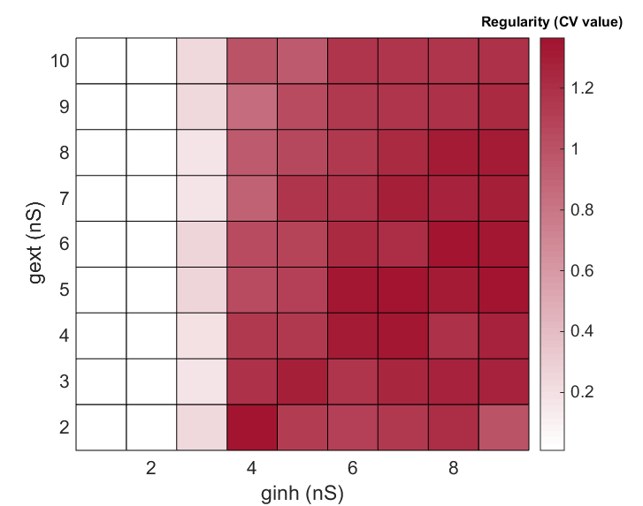K-means analysis is used as objective classification method why? What is this?. The elbow method is used to determine the number of clusters (see: methods). As shown in Figure 5, the flipping point is at 3 clusters, so k-means will be performed with 3 clusters. Ik zou ook wel benieuwd zijn naar een figuur waarbij de y-as iets kleiner is. The analysis reveals 3 clearly separated clusters (figure 5): The SR state (green), a transition state where some neurons are still in the SR state whereas other are more silent (yellow) and an AI state, where irregular neurons fire asynchronously (blue). Where is the bursting state in this picture?

**Figure 4. Plots of the degree of regularity (left) and synchrony (right) of balanced networks with more complex neurons with different parameter sets.** On the left the regularity of the network is plotted for the parameters . On the right the same ranges are used, but now the degree of synchrony is plotted.

Discussion

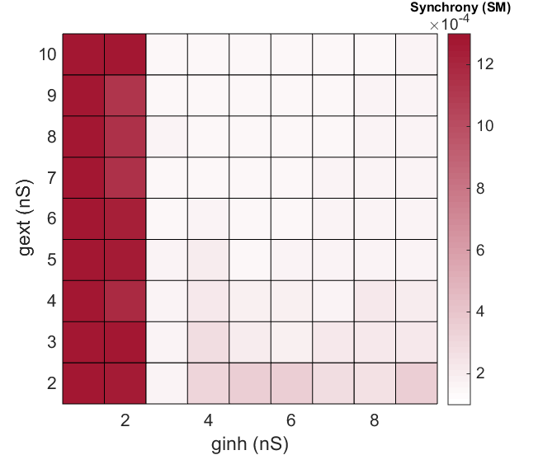After four different balanced states of the simple small network model were found, I examined whether a more complex synapse model could settle in these same four different states, based on regularity and synchrony. Cluster analysis showed that there were merely three different states. So there is a synchronous regular state, a transition state and an asynchronous irregular state. This is probably because this network shows a different global activity: bursting behaviour. So the more complex model could reach balanced states, but the behavior differs a lot from the simple neuron model, as the more complex model shows strong bursting behavior.

This difference in behavior could have several causes. Firstly, the adjusted synapse model, which makes the network more complex, could explain the difference. This conductance model, in which the conductance decays exponentially, causes a long-lasting postsynaptic membrane depolarization after a spike, keeping it close to threshold when a following spike arrives. This positive feedback causesa high frequency firing, hence the initiation of a burst. Since the time constant of the inhibitory synapse is higher, which means the inhibitory neurons remain longer sensitive so eventually the burst is inhibited and there is some time no spiking. After some time the inhibitory conductance decays, and the external input is strong enough to intitialize a burst again.

Besides this explanation, there is one other difference between the extended network and the original balanced network from Brunel (2000) which could have a major influence: the more complex network model has initial conductance weights drawn from a Gaussian distribution, whereas the original model all weights are the same. In the network 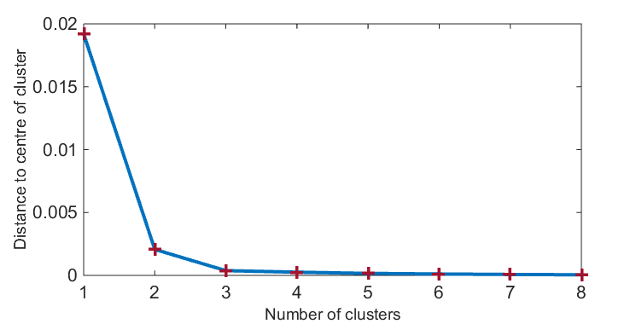behavior this is represented in the transition states, which is more present in the more complex model. This distribution of conductance values causes that there are neurons with low conductance and neurons with high conductance. This means that when increases some neurons with a high initial conductance still receive enough external input to fire regularly, whereas the neurons with a lower conductance receive too little external input en start firing less. This causes less regularity and synchrony, but enough to prevent the bursting state.

**Figure 5.** **K means analysis of the more complex neuron model to cluster based on regularity and synchrony.** On the left the elbow method is shown. The flipping point is at 3 cluster, which means that 3 clusters are used for the k means analysis. On the right the output of the k means analysis is shown. Three clusters are grouped based on regularity and synchrony. The green cluster is the SR state, the yellow cluster the transition state and the blue cluster the AI state.

Thirdly, there could be an effect of network size!

Moreover there is a whole range of other parameter set used for the more complex neuron model compared to the simple model. Two different models are used so it is impossible to explain the influence of every parameter. It is probable that the two parameters previously discussed have the biggest share in the different behavior, especially because this could be theoretically explained. However, it should be kept in mind that these two parameters are not the only candidates.

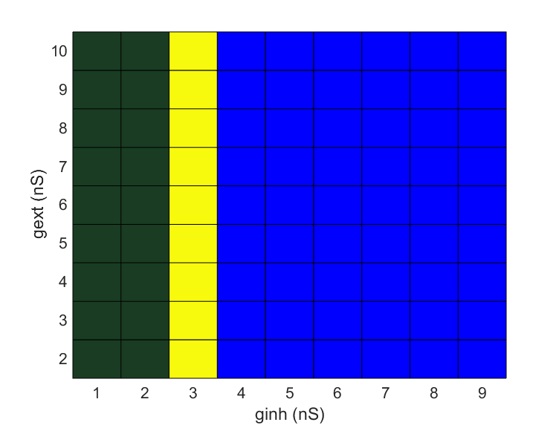The simple network model, thoroughly examined by *Brunel, 2000,* was used to examine irregular behavior of a network in order to investigate the causes of irregular neural activity in the human brain. In this study, an adaptation of the model of *Yger & Harris, 2013* is quantified to research the regularity and synchrony of this extended model, and appears to behave as an asynchronous irregular network as well. As this is a more biological plausible network, it could be used to examine the influence of different biologically relevant properties, such as synaptic strength, connectivity patterns and …(verzin nog maar wat leuks) on the behaviour of such neural networks.

Future studies can show what the influence of other parameters is on the activity of a balanced network, especially the irregular asynchronous state. Furthermore, more realistic components of neurons or synapses can be added and their influence examined. With the continuing growth of the computational power, more detailed models of neurons can be connected in large scale networks and simulations can still be run in a reasonable time. This could give more insight in how these networks behave and how their is formed, and this will result in a better understanding of the computations made in the human brain.

In this paper/thesis, we /I examined whether a extended network/synapse model can reach balanced states similar to Brunel (2000). It was shown that this more complex model shows asynchronous irregular behaviour, but that this behavior is different (bursting), due to extra biological plausible characteristics. This model and extensions of it can be used to examine the influence of what ? be specific! of a neuron on the network activity. Future research can help to understand the underlying mechanisms of this activity and therefore get more insight in the computations of the human cortical brain.

References

Brunel, N. (2000). Dynamics of sparsely connected networls of excitatory and inhibitory neurons. *Computational Neuroscience*, *8*, 183–208.

Golomb, D., & Hansel, D. (2000). The number of synaptic inputs and the synchrony of large, sparse neuronal networks. *Neural Computation*, *12*(5), 1095–1139. http://doi.org/10.1162/089976600300015529

Goodman, D. F. M., & Brette, R. (2009). The brian simulator. *Frontiers in Neuroscience*, *3*(SEP), 192–197. http://doi.org/10.3389/neuro.01.026.2009

Izhikevich, E. M. (2004). Which model to use for cortical spiking neurons? *IEEE Transactions on Neural Networks*, *15*(5), 1063–1070. http://doi.org/10.1109/TNN.2004.832719

Ketchen Jr., D. J., & Shook, C. L. (1996). The application of cluster analysis in strategic management research: An analysis and critique. *Strategic Management Journal*, *17*(6), 441–458. http://doi.org/10.1002/(SICI)1097-0266(199606)17:6<441::AID-SMJ819>3.0.CO;2-G

Remme, M. W. H., & Wadman, W. J. (2012). Homeostatic scaling of excitability in recurrent neural networks. *PLoS Computational Biology*, *8*(5). http://doi.org/10.1371/journal.pcbi.1002494

Shadlen, M. N., & Newsome, W. T. (1998). The variable discharge of cortical neurons: implications for connectivity, computation, and information coding. *The Journal of Neuroscience : The Official Journal of the Society for Neuroscience*, *18*(10), 3870–3896.

Softky, W. R., & Koch, C. (1993). The highly irregular firing of cortical cells is inconsistent with temporal integration of random EPSPs. *The Journal of Neuroscience : The Official Journal of the Society for Neuroscience*, *13*(1), 334–350.

Yger, P., & Harris, K. D. (2013). The Convallis Rule for Unsupervised Learning in Cortical Networks. *PLoS Computational Biology*, *9*(10). http://doi.org/10.1371/journal.pcbi.1003272

http://www.yger.net/the-balanced-network/)